

**Faculty of engineering - Shoubra**

**Benha University**

**Research Article / Research Project / Literature Review**

in fulfillment of the requirements of

|  |  |
| --- | --- |
| **Department** | Electric |
| **Division** | Communications |
| **Academic year** | First |
| **Course name** | Computer application (1) |
| **Course code** | ECE 124C |

**Title: -**

Research Project: Web Site using HTML, CSS, and JS

By:

|  |  |  |
| --- | --- | --- |
| Name | Edu mail | B.N |
| محمود محمد عطية | Mahmoud180810@feng.bu.edu.eg | 141084 |

**Approved by:**

|  |  |
| --- | --- |
| Examiners committee | Signature |
|  |  |
|  |  |
|  |  |
|  |  |
|  |  |

**Introduction**

I made a website about football and named it as **scoregoal.** This website consists of five pages, where the first page includes the form in the welcome page to sign up if you do not have an account and another small form to sign in if you already have an account.

The other four pages are talking about football championships and historical numbers from beginning of football. In the second page I talked about world cup which began in 1930 and I made a table containing the champion of each competition and the year of this event.

Third page is also like first but about ballon dor award. I talked about ballon dor each year and the winner of it.

Fourth page is about Puskás award and the winner of it with the video of the winner goal.

Last page is a great comparison between Messi and Ronaldo in many things : teams, goals and assists, hatricks and last thing is trophies of each one.

**Link:** <https://github.com/mahmoud244/ECE124C>

**Website**

**First page:**

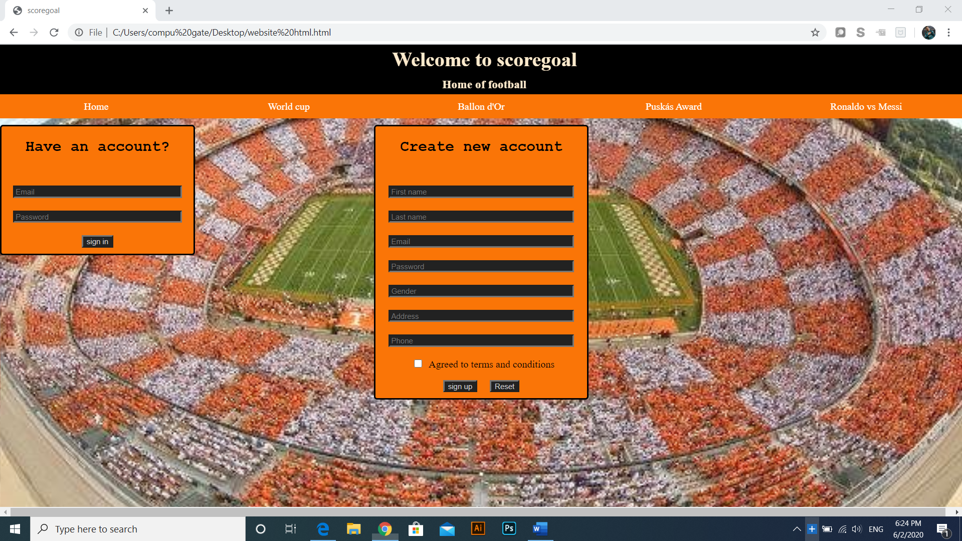

This is the first page which contains two forms: small form if you have an account and big form if you need to create an account.

This big form contains first name, last name, email, password, gender, address and phone number, but there are some conditions for password by java script to continue:

-Password must consist of 8 characters.

-first letter must be capital.

-password must contain one number at least.

-password must not contain any space .

-password must contain special character.

Phone number also has some conditions by java script to continue:

-Phone number must be 11 number not characters nor letters.

-Phone number must not contain spaces.

I made navigation bar by unordered list and some changes with CSS like float property to be left for the lest items and let the links into the items to display as blocks, then I made the color of hover for them orange but more darker to be different if any one move the cursor on it.

Higher than this navigation bar there is a big div with text saying “welcome to scoregoal”

And “Home of football”.

I made a bigger div containing the div with text and the navigation bar and changed the position property to be sticky to make the moving between the pages easier to the user and I toke same code for this big div for all pages.

**Second page:**

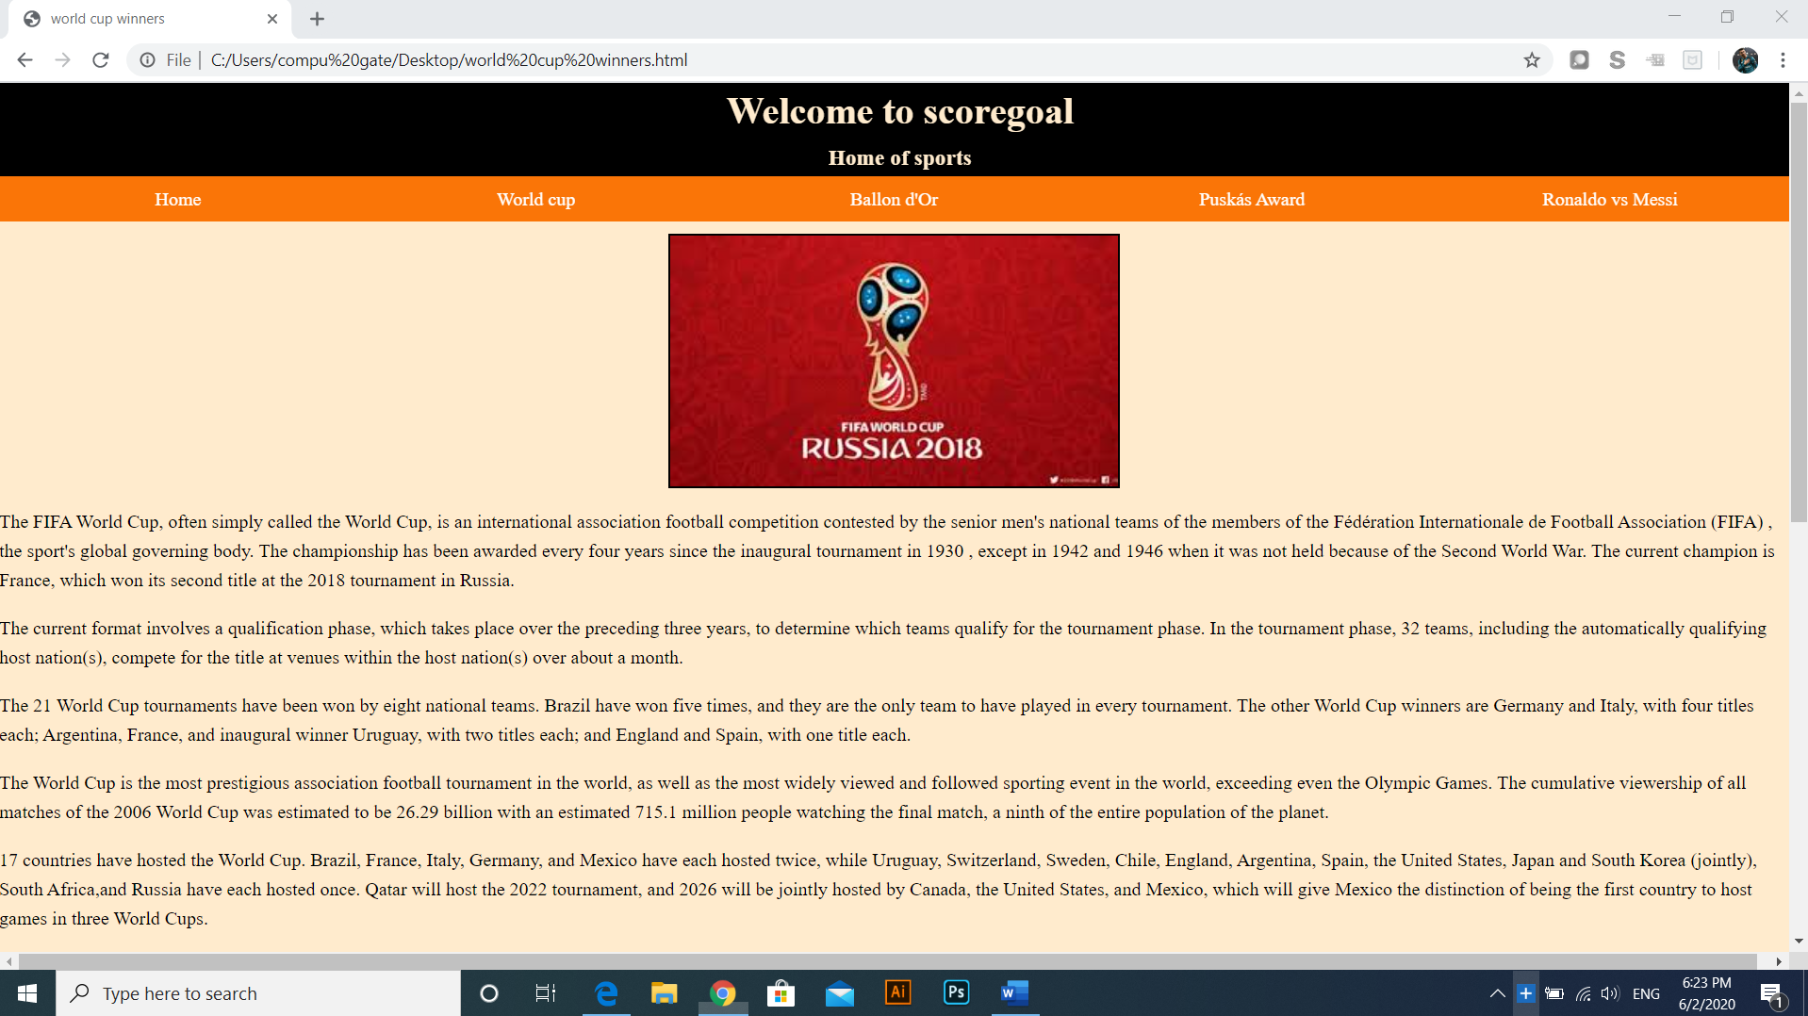

This is the second page which talking about world cup. I put an image with margin auto and some paragraphs about world cup and its beginning at 1930.

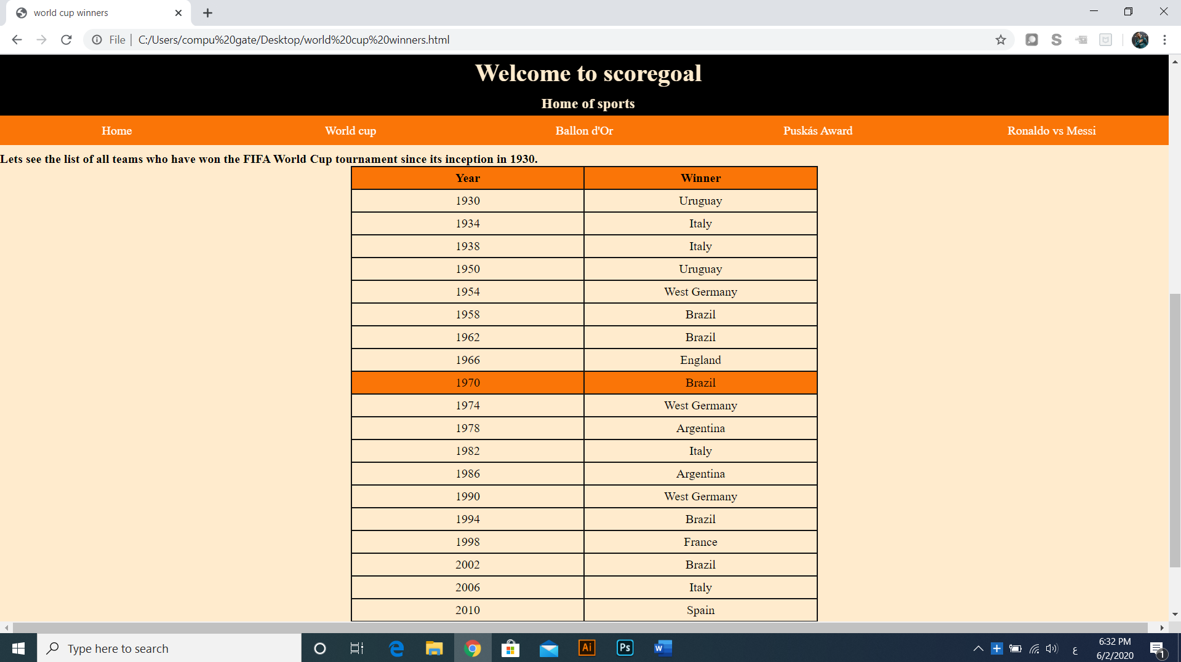

Then I made a table containing every competition of world cup and the winner of it. I made table header which background color like orange and made every table row be the same color at hover only like the previous figure.

**Third page:**

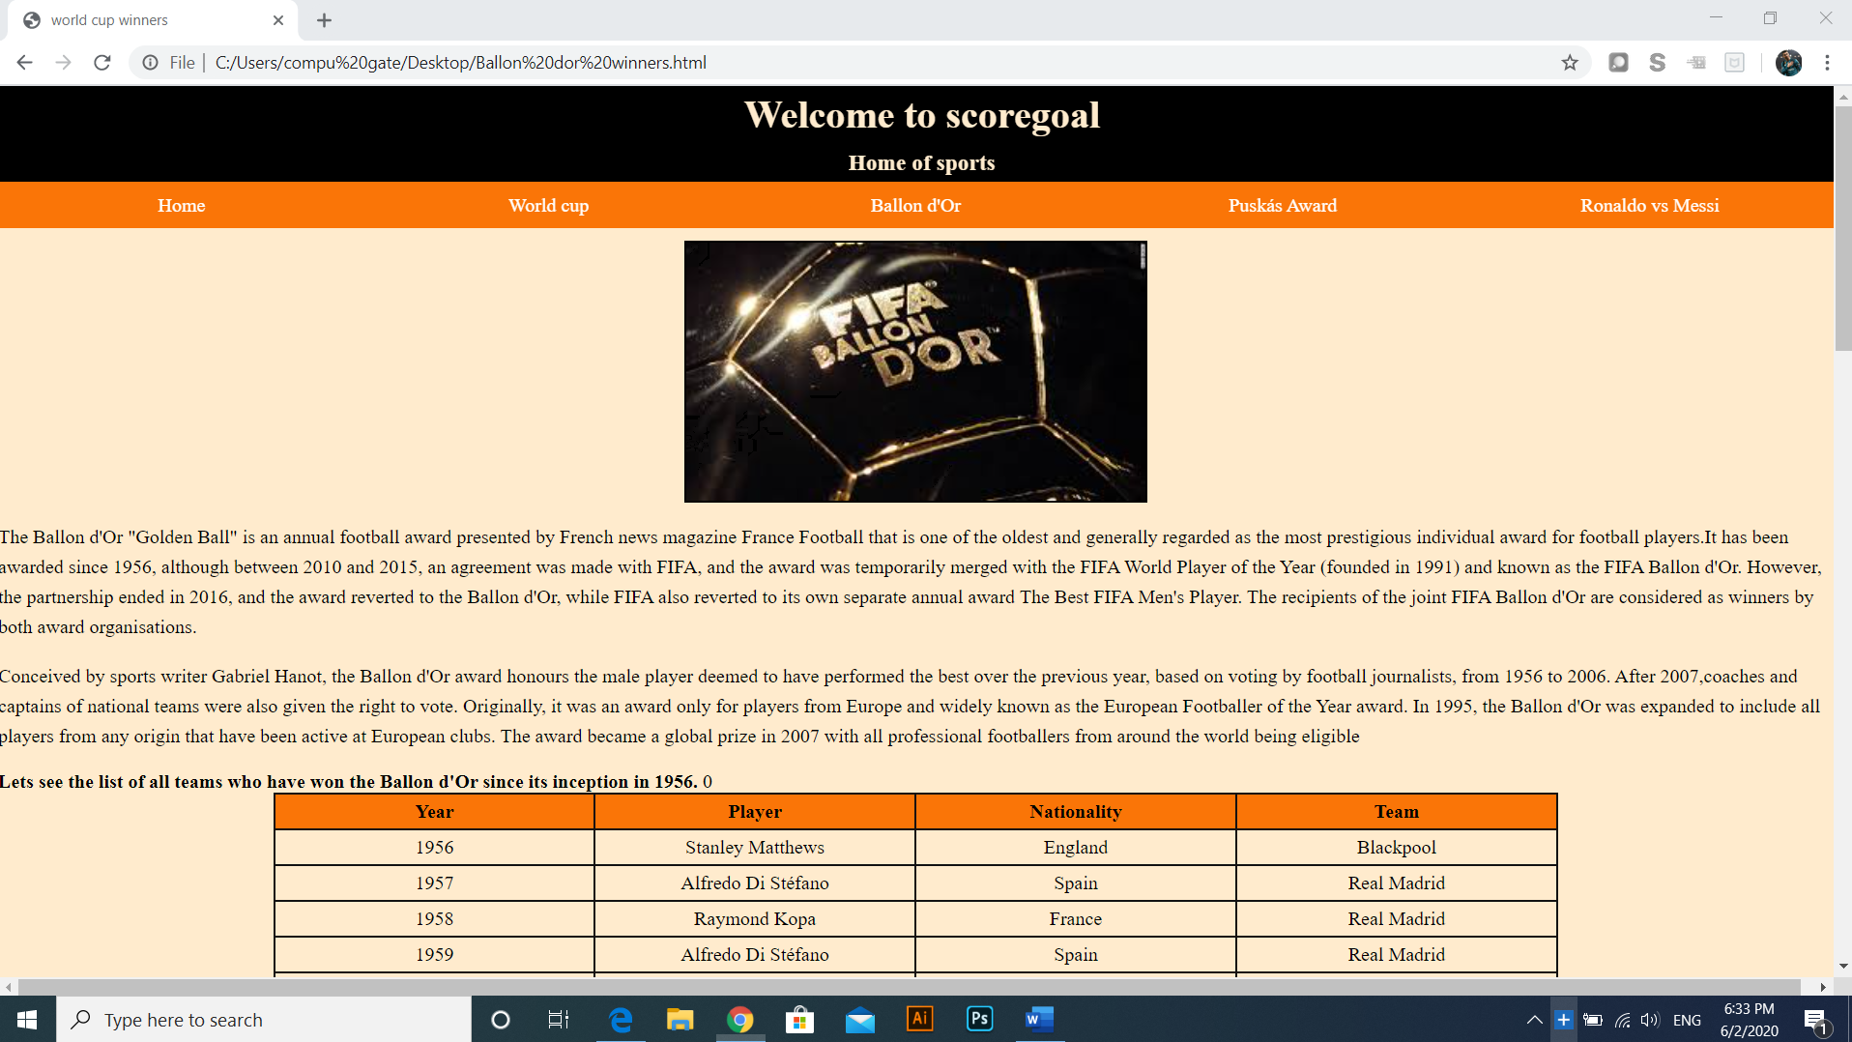

This is the third page which talking about ballon dor award for best player of the world every year.

I put an image shows the award with margin auto to be at center of the page horizontally

And many paragraphs.

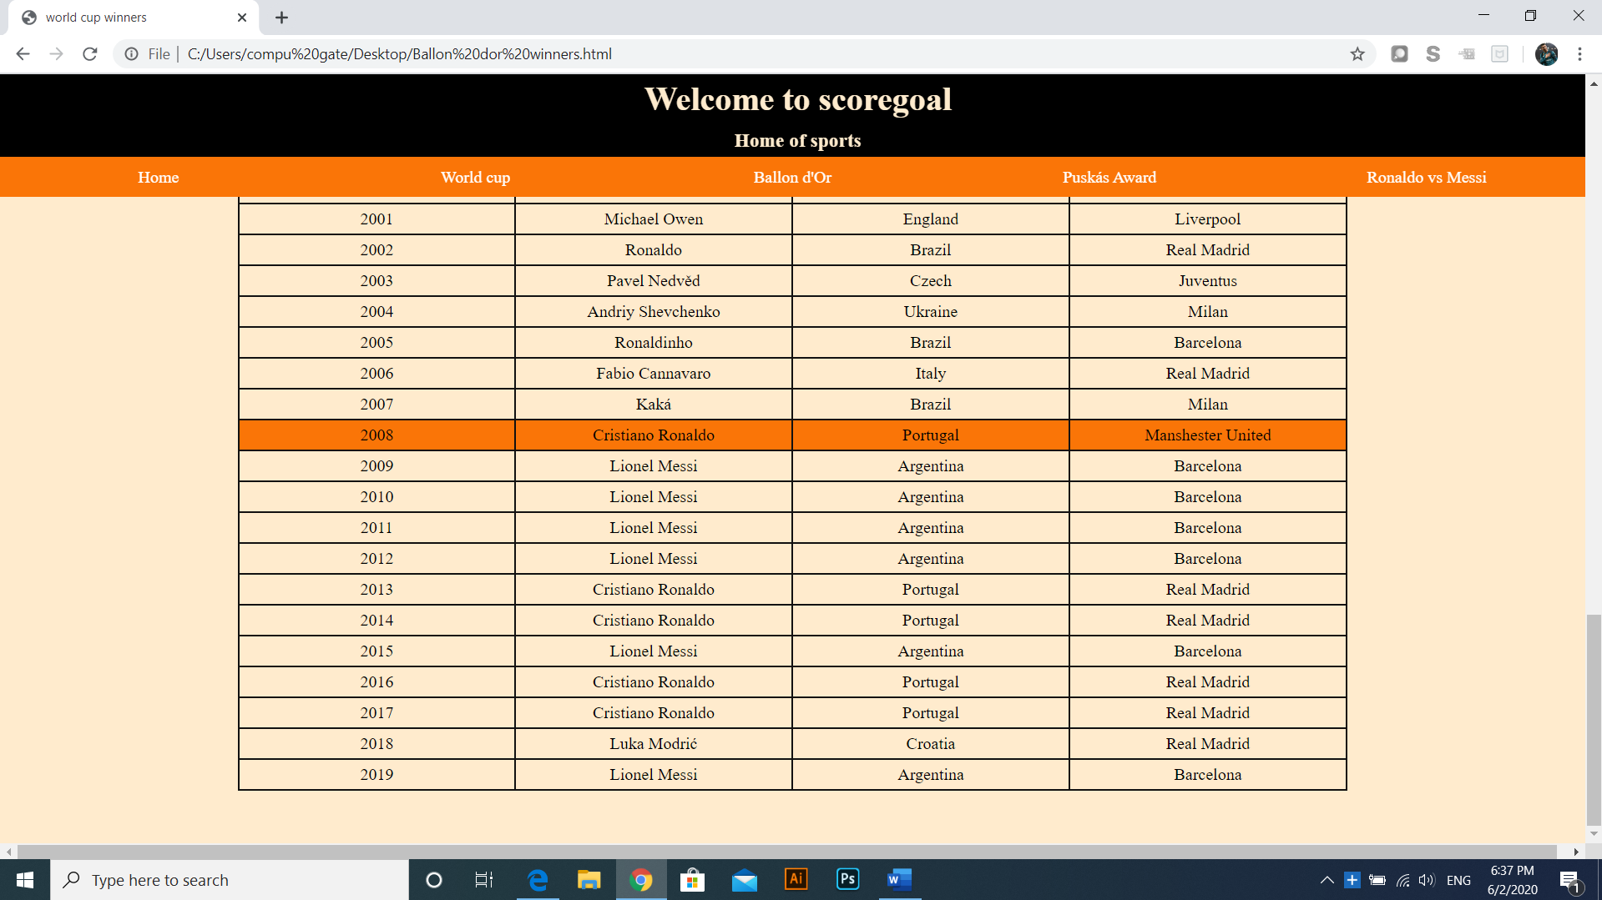

Also, for this page I made a table containing all ballon dor awards from 1956 to now with margin auto and same headers and cells like the table of second page.

**Fourth page:**

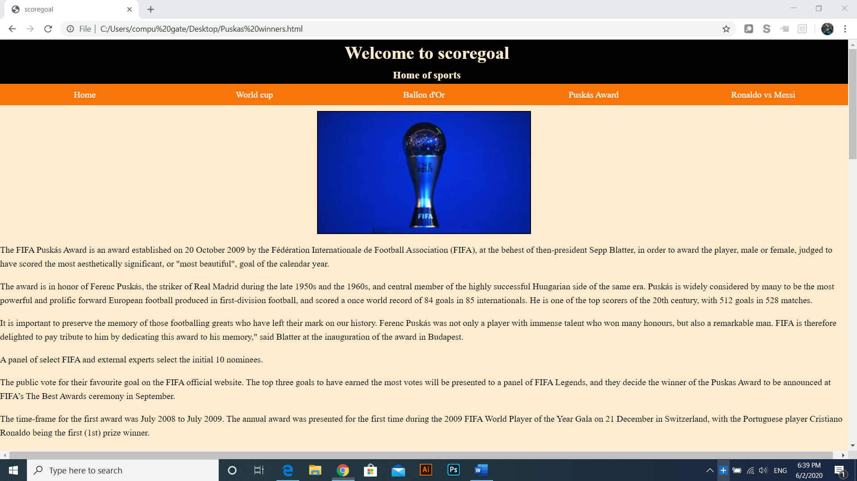

This is the fourth page. It contains Puskás award and some information about it.

There is also an image at center of the screen and some paragraphs discussing this award and how it began.

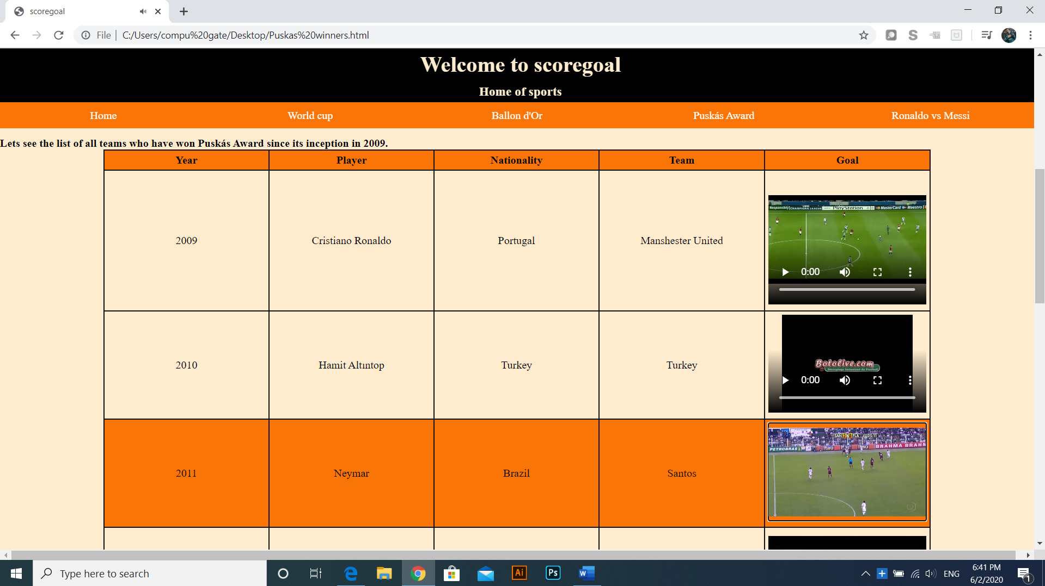

I here made bigger table containing video of the goal winning this award every year which the user can control it to stop or continue and make it full screen.

I made headers and cells the same as the two previous tables also but the columns are more to contain the year, player scoring winning goal, his nationality, his team and last thing is the video of the winning goal from 2009 to now.

**Fifth page:**

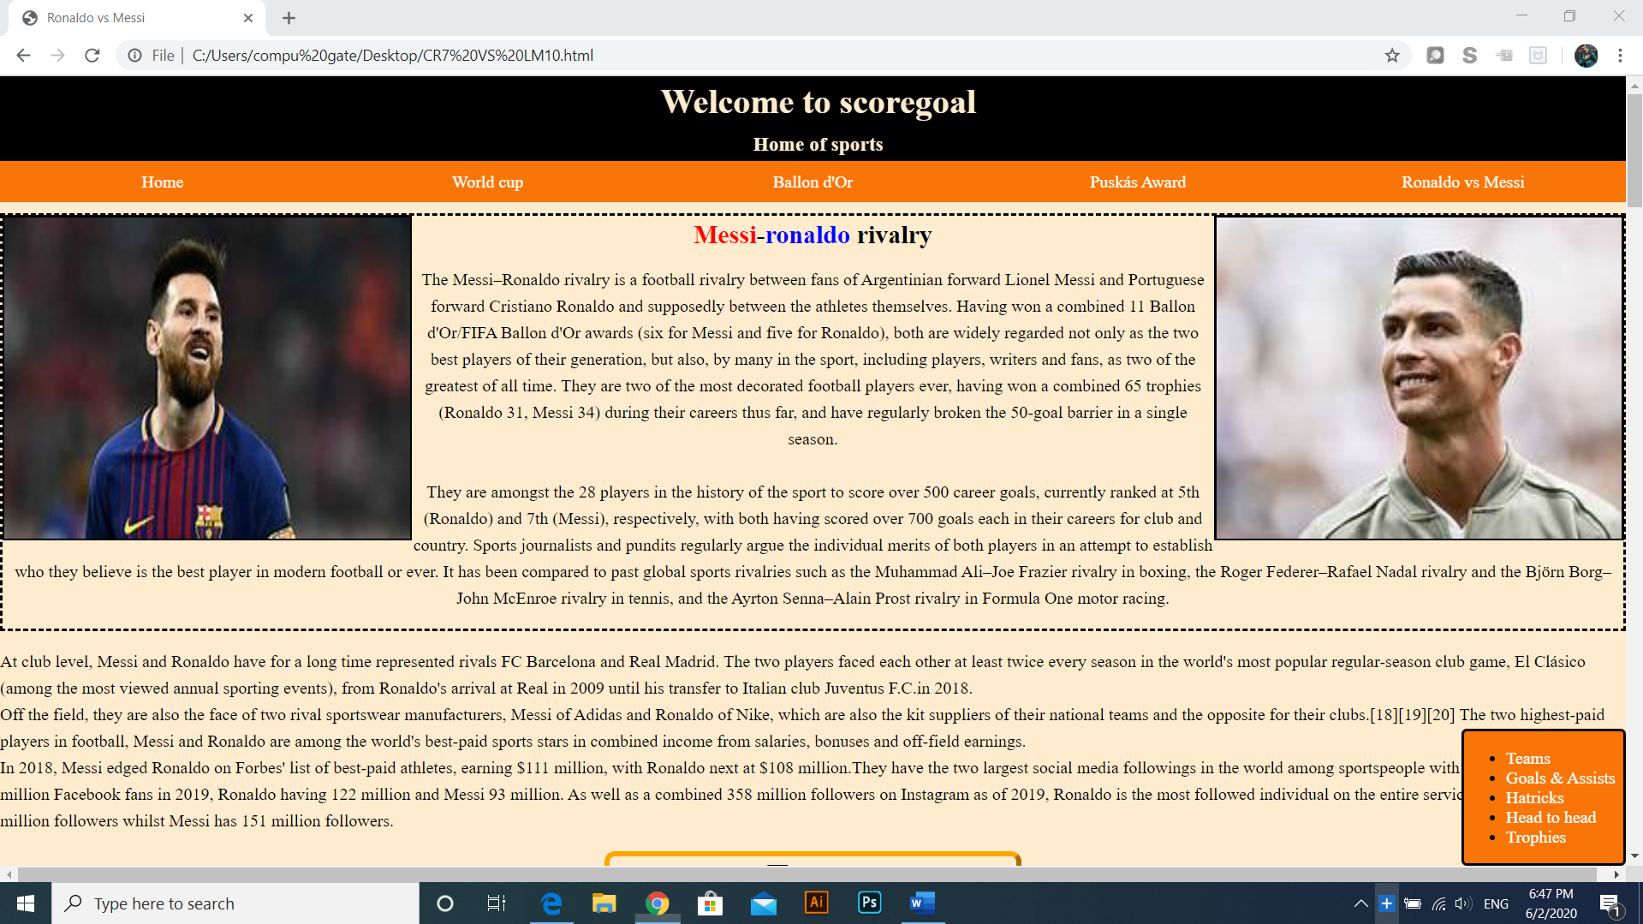

This is the fifth and the last page of my website. It is the biggest page of all five pages. It contains enormous comparison between Messi and Ronaldo.

I made a div containing these two images, where one is float left and the second is float right and paragraph between the two images and some paragraphs outside this div.

I made a div with property position fixed with bottom zero and right zero to be in the bottom right corner of the page. This div contains unordered list with bookmarks for each part of this page because of its big size.

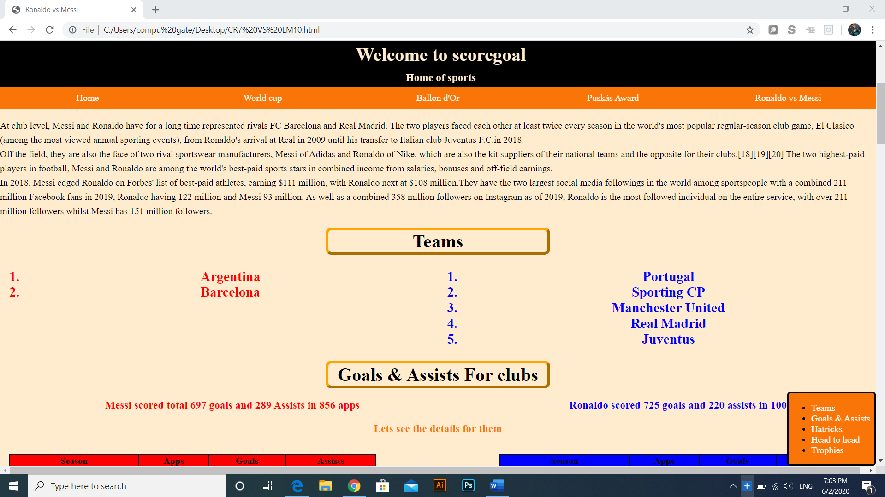

I put in this page some h1 elements with orange outside border and I put property of border radius for it and margin auto. Each one of these h1 elements as bookmark in the bottom right fixed div.

Under this element with containing the word “teams” I made two ordered lists with the teams of the two players with width 50% of the width of the page for each list.

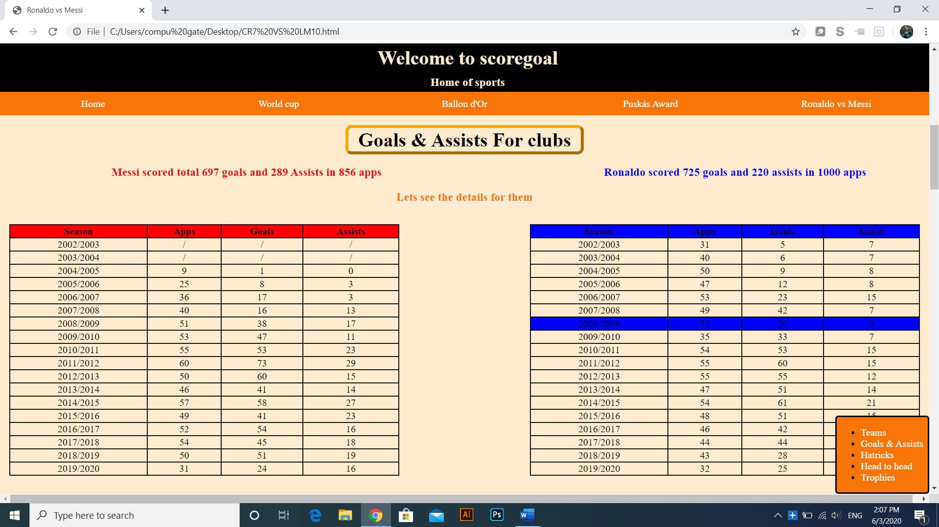

After the two ordered lists I put another h1 element for goals and assists and I put red text by h3 element for Messi in the left with margin left 12% and width 53% and beside it another text but blue for Ronaldo. The margin and width for red make the two h3 elements be at center of the page.

There is also orange h3 element with text align center.

Then, I put two tables one has property float left and the another has property float right. Each one of them has width 42% of the page and margin 1%.

I made the headers of the left one be red and of the right one be blue. All cells of the left one in hover will be colored red as the header and the same for the right one as all cells in hiver will be colored blue.

In the screen, I put the cursor on the right table to show the hover case of the cells of this table.

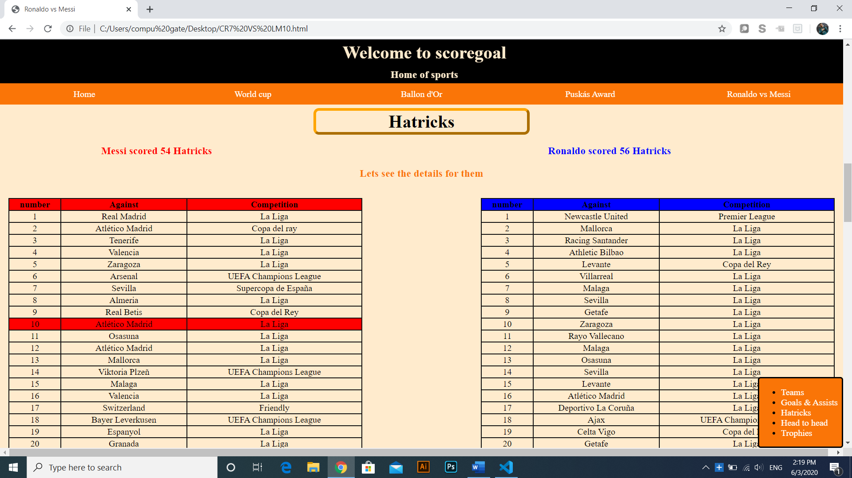

Here I made same thing as the previous part: I put three h3 elements colored by red, blue and orange and have the same properties.

I made the same table properties for the two tables, but they are about Hatricks for the two players and in the screen, I put the cursor on the left table to show the hover case of the cells of this table

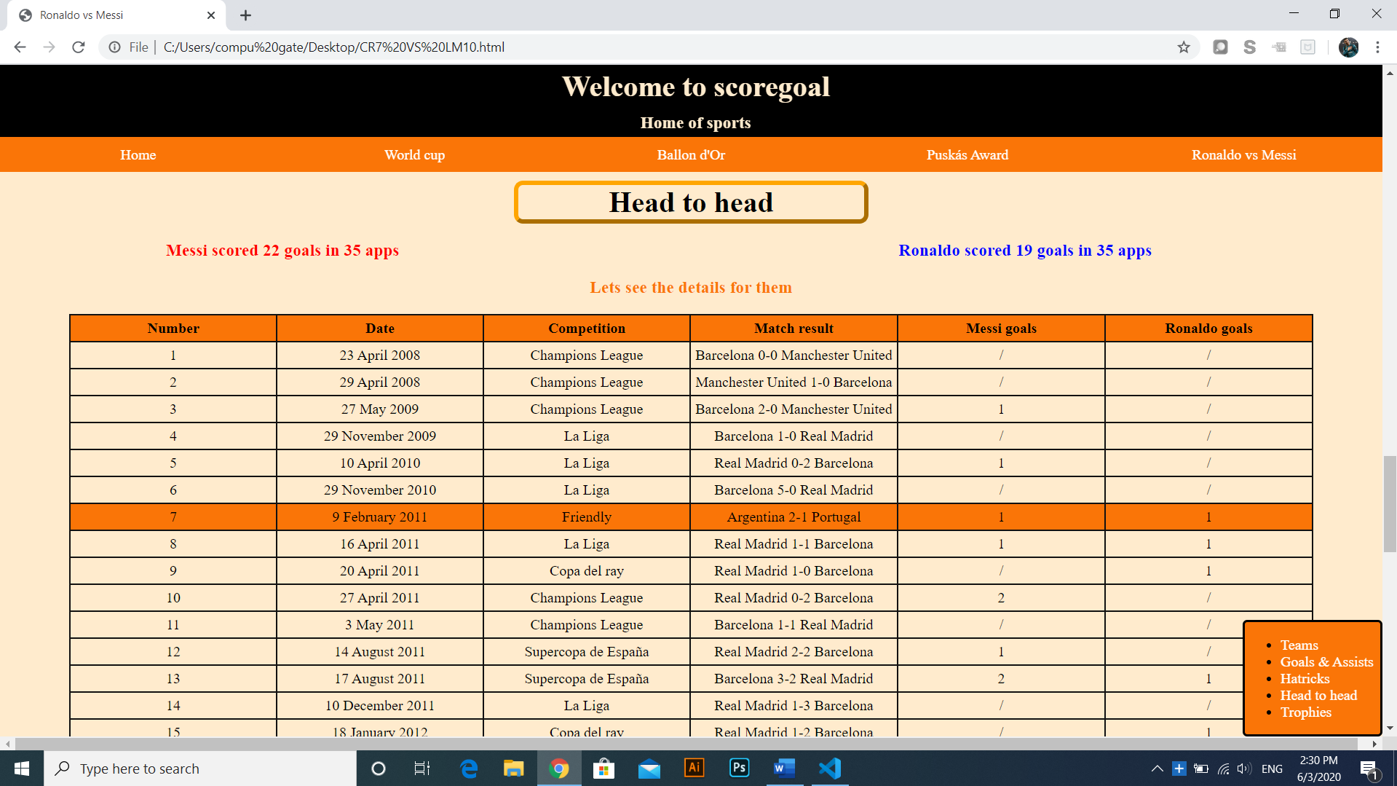

After that, I put another h3 element with same border and text align, I made same three h3 elements as the two previous screens.

Now, I put one table not two as previous screens as I made it for head to head matches between the two players with cells of the table about date of match, competition, final match result and goals for Messi and Ronaldo in this match.

This table has 6 columns, so I provided it with big width of 90% and margin auto to be at center of the page.

For this table, I made the hover property be orange for rows as the row of headers which is orange too but always not in hover only.

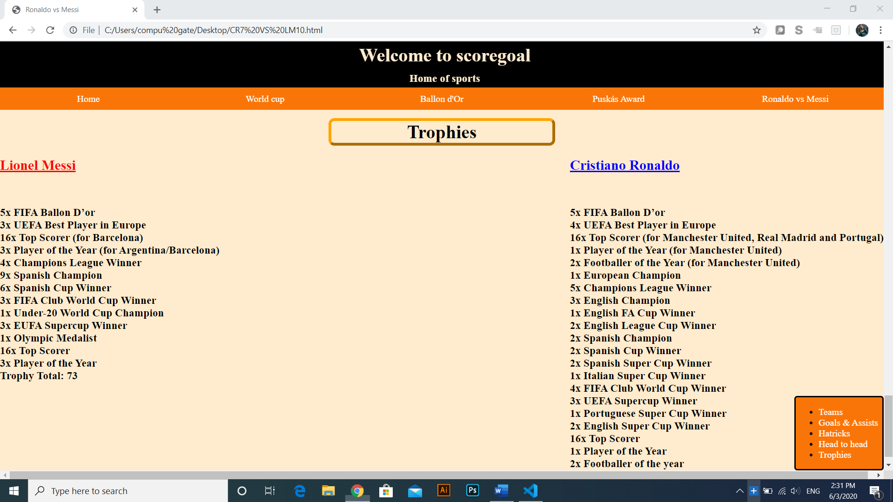

This is the last part of the big fifth and last page of my website. I made h1 element with same properties for trophies.

I made a div in the left with property display inline block to allow the another div to be beside him and I made the another div be float right to show them as one in the left and one in the right.

For each one I put h2 element: one is red for the left and one is blue for the right. The two h2 elements have the property text decoration underline.

In each div under the underlined h2 element, there is h3 elements talking about all trophies of the two players. The h3 element are separated by <br> to make each element in one line.